Histograms and Boxplots Classwork

1. 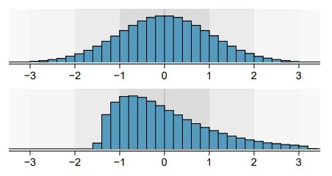Are the following histograms left skew, right skew or symmetric?

Answer:

The first is symmetric.

The second is right skewed.

1. Comparing Boxplots

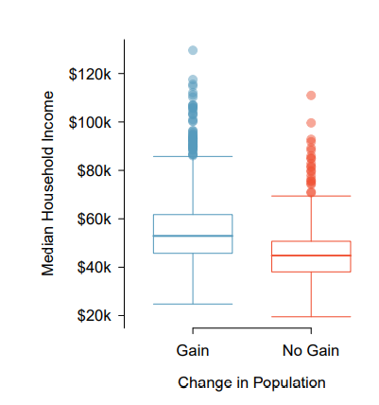

a) Find the median, lower and upper quartiles for both box plots. Use this to find the IQR.

b) Which boxplot has a higher IQR? (bigger box)

c) Which boxplot has a higher range?(longest plot)

d) Are these box plots left skewed, right skewed or symmetric?

(Hint: imagine drawing a histogram from the data.)

Answer:

|  |  |  |
| --- | --- | --- |
| No Gain | Gain |  |
| 45 | 55 | median |
| 35 | 45 | Lower |
| 50 | 62 | upper |
| 15 | 17 | IQR |

a.

b. The Gain has a higher IQR.

c. The Gain has higher range.

d. If plotting with outliers, it would be right skewed else they’re symmetric.